# CS 255 System Design Document Template

## UML Diagrams

### UML Use Case Diagram

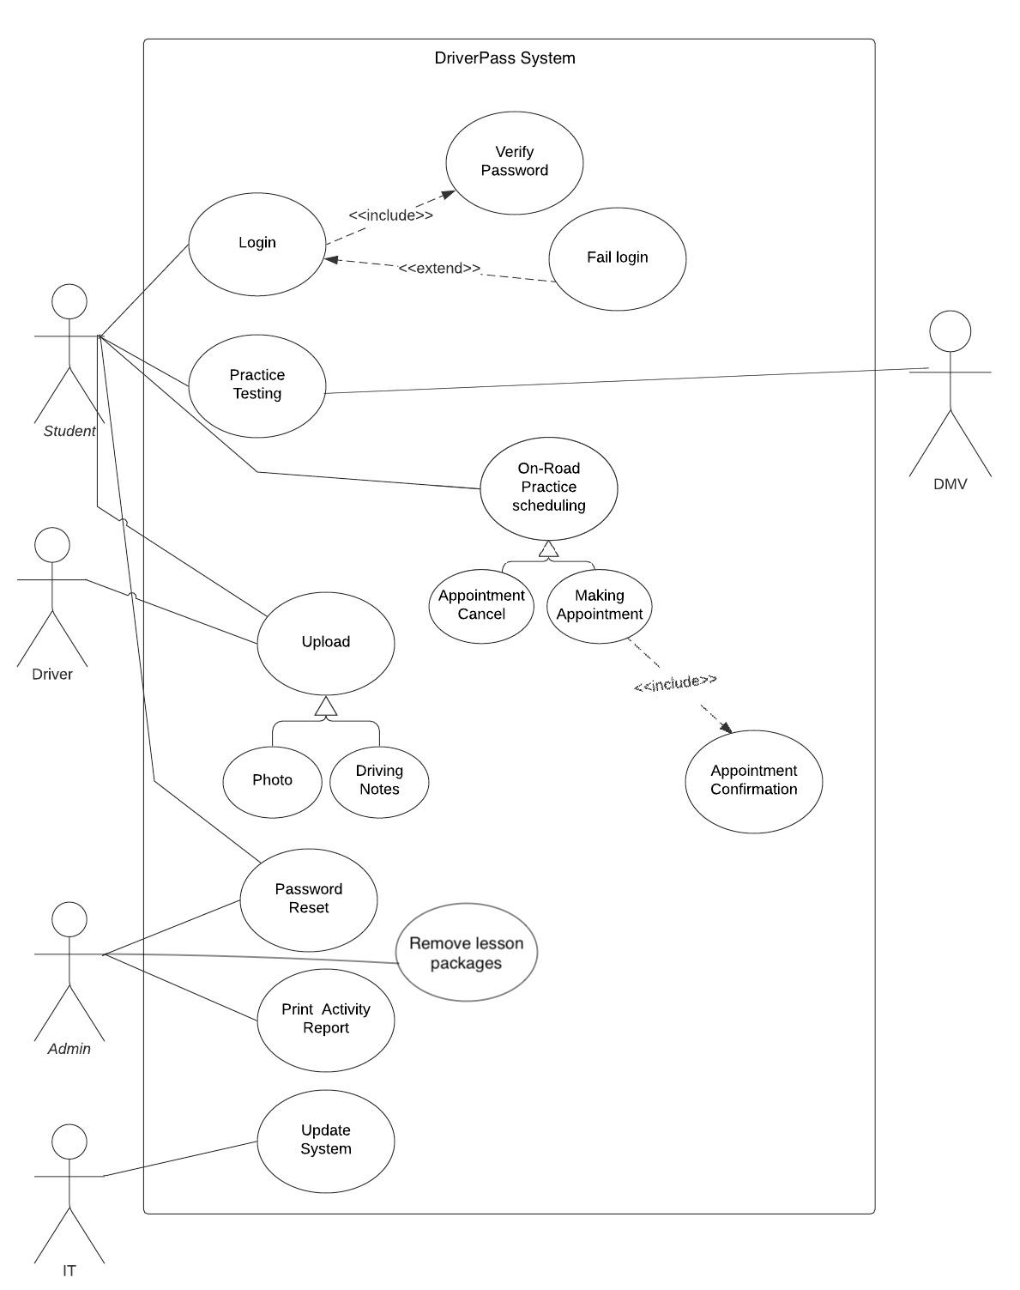

### UML Activity Diagrams

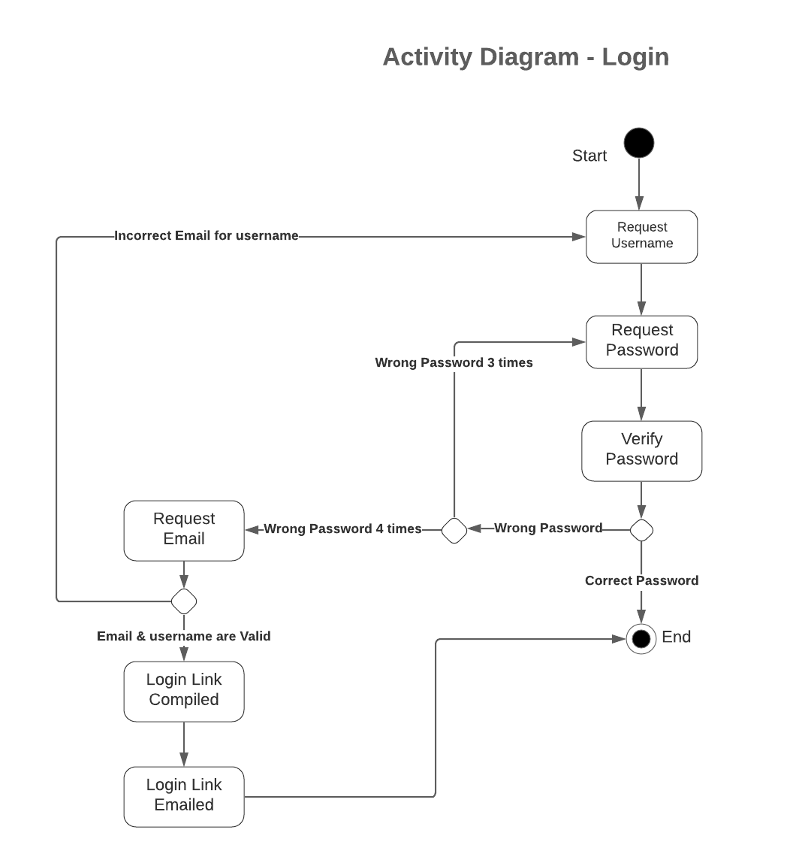

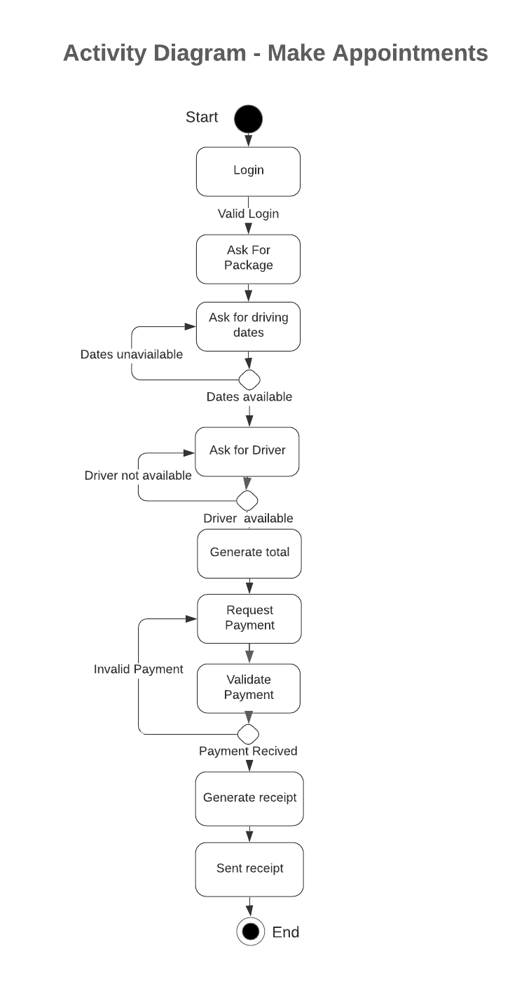

### UML Sequence Diagram

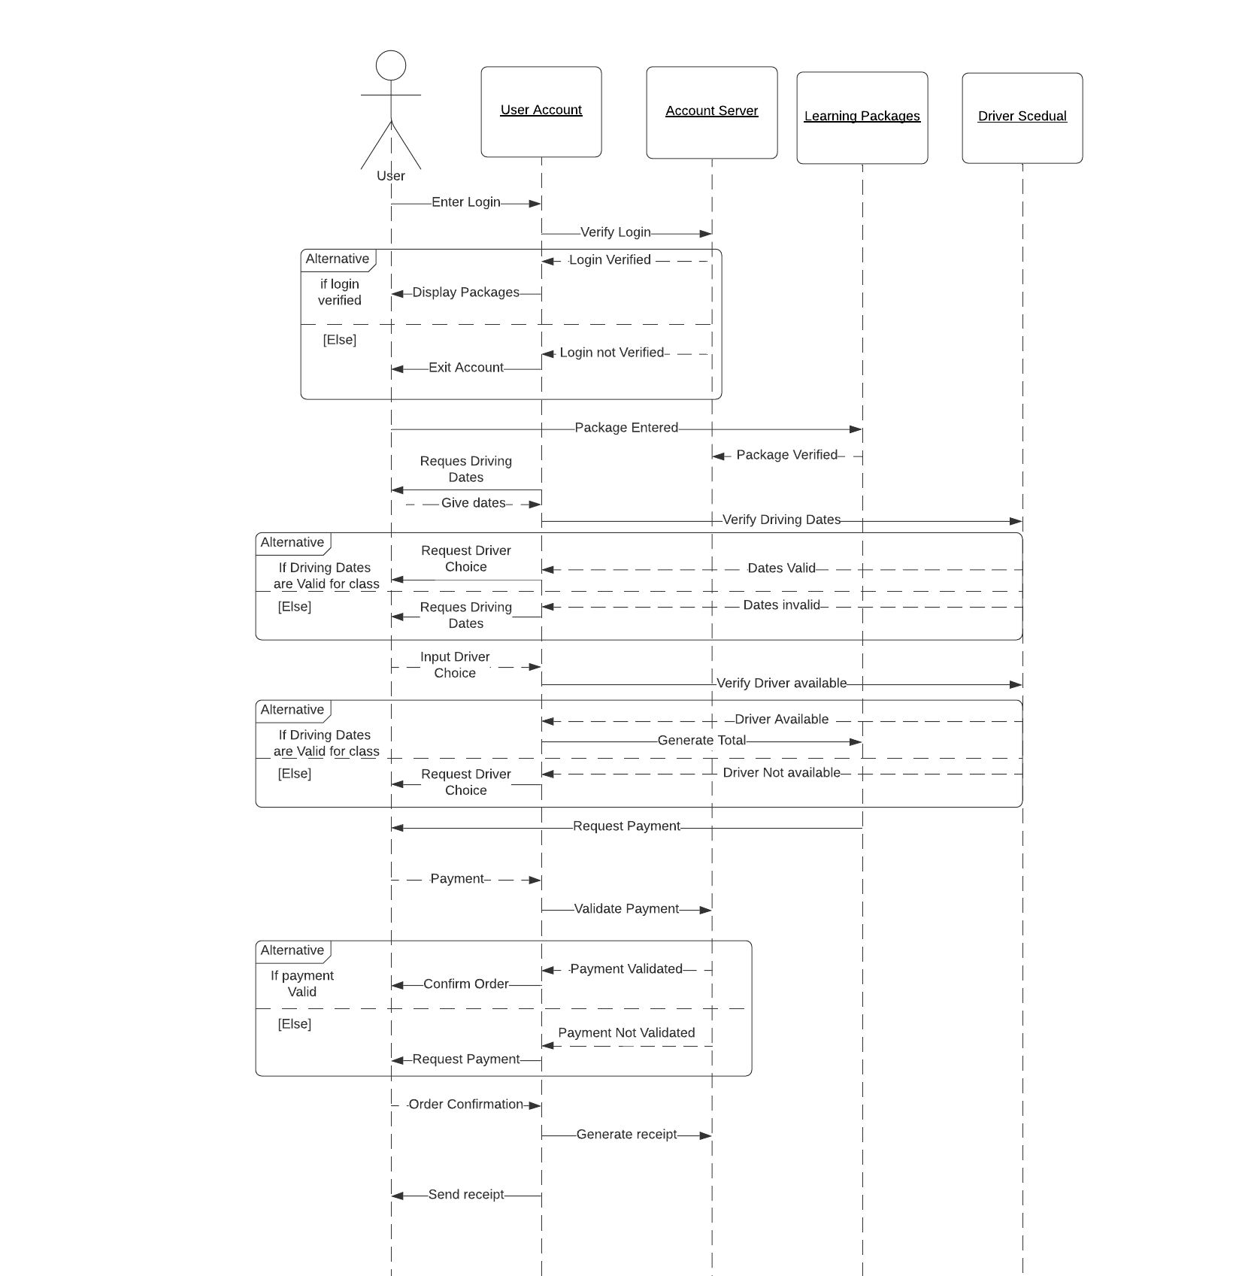

### UML Class Diagram

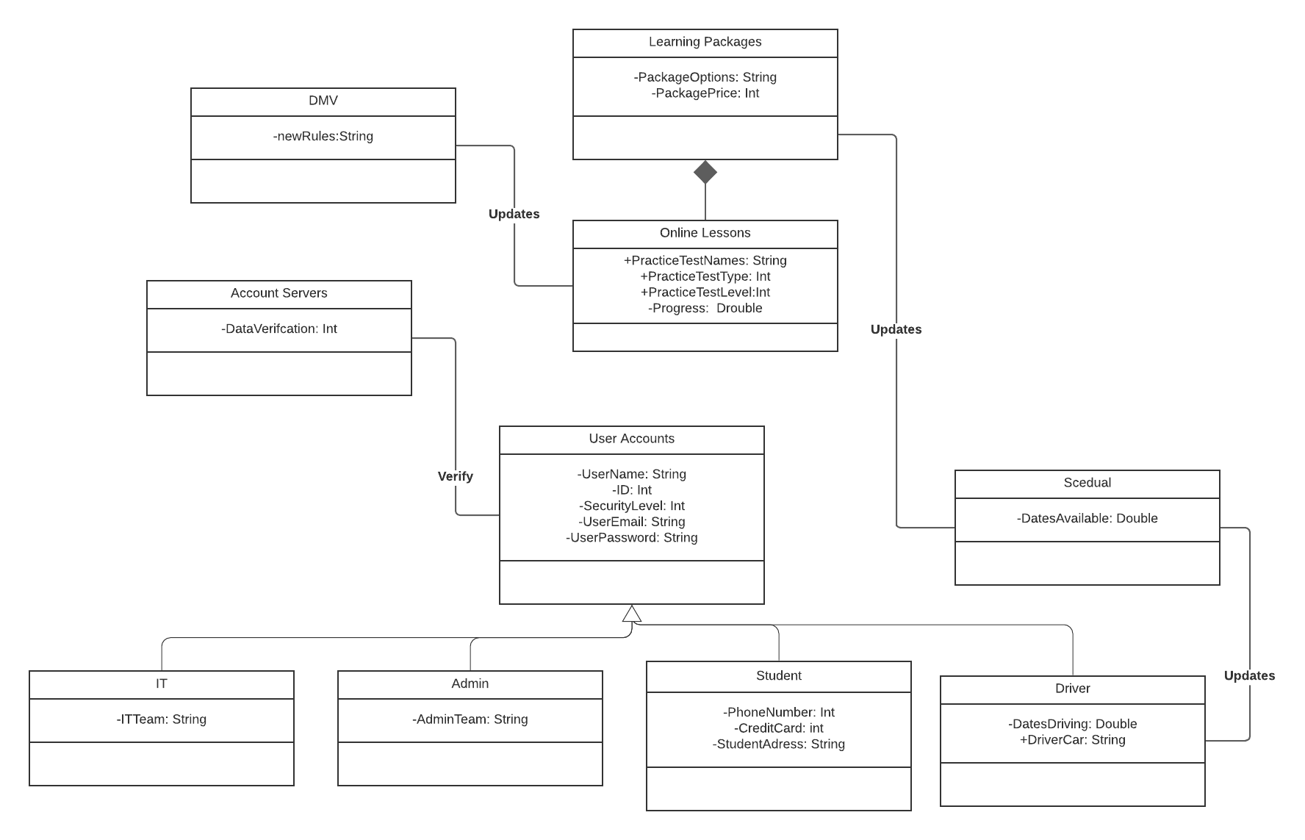

## Technical Requirements

*Hardware:*

*Computer*

*Server*

*Software:*

*Cloud Server Space*

*IDE for the programing language being used to develop the system*

*API or multiple APIs to provide cloud interface, graphical interfaces, etc.*

*Implementations of security hashes, algorithms, etc.*

*website/web hosting/domain information for use in program construction.*

*Other:*

*Security procedures*